I B.Tech II Semester Supplementary Examinations, November, 2023
SEMICONDUCTOR PHYSICS AND DEVICES
(ECE)

Time: 150 Min Max. Marks: 80M

SECTION – A
Answer all Four questions 4×10M=40M

1.a) Compare the V-I characteristics of a germanium and a silicon diode graphically with respect to Temperature variations
b) Analyze the forward voltage drop across the diode whose characteristics appear in Fig. 1 at temperatures of -75°C, 25°C, 100°C, and 200°C and a current of 10 mA. For each temperature, determine the level of saturation current. Compare the extremes of each and comment on the ratio of the two.
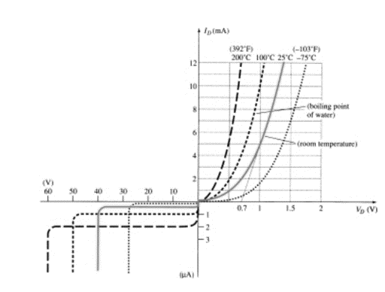
Fig. 1

2. Voltage regulator is shown in fig 2where Vs is an unregulated voltage that varies between 6V and 7V while the Zener diode voltage is V_{Z} = 5 V. The load resistor R_{L} can have a value from 100 Ω to ∞ (i.e., open circuit). Also you can take I_{Z}(min) ∼= 0 A.
a) Identify the maximum value of R₁ so that the load voltage V_{L} would be still kept constant at 5V for all values of R_{L} and V_{s}.
b) Provide a symbolic expression for the maximum power dissipated by the Zener diode.
c) Identify the minimum value of R₁ so that the power dissipated by the Zener diode does never exceeds 1W for all values of R_{L} and V_{s}
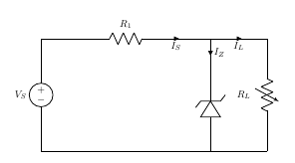
Fig 2

3. Design a DC Power Supply using half-wave and bridge for the following specifications.
- Power source:220V, 60Hz, single phase AC.
- Output current: 2000mA Max
- Output voltage: 5 V_{DC}
- Ripple Voltage: less than 0.5V for all currents

4.Calculate the voltage gain ($A_{V}={V_{L}}/{V_{i}}$) for the network of Fig.3 if Vi=500 mV and R=1 kΩ. (The other circuit values remain the same.)
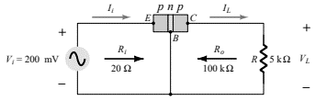
Fig. 3

SECTION – B
Answer all Two questions 2×20M=40M

5.a) Draw the experimental setup of CE amplifier to obtain the input and output characteristics
(b) Using the characteristics of Fig. 4, determine h_{fe} at I_{C} = 6 mA and V_{CE} = 5 V.
(c) Using the characteristics of Fig. 5, determine h_{oe} at I_{C}= 6 mA and V_{CE}= 5 V.
(d) Using the characteristics of Fig. 6, determine h_{ie} at I_{B}= 20 µA and V_{CE} =20 V.
(e)Using the characteristics of Fig.7, determine h_{re} at I_{B} =20µ A.
(f)Using the characteristics of Figs. 4 and 5, analyze the approximate CE hybrid equivalent model at I_{B}= 25µA and V_{CE} =12.5 V
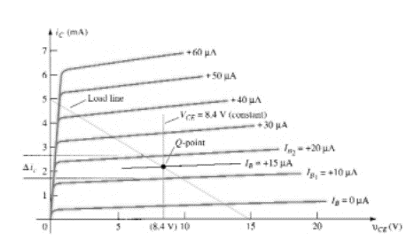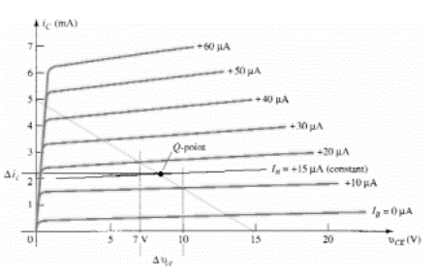
Fig.4 Fig.5

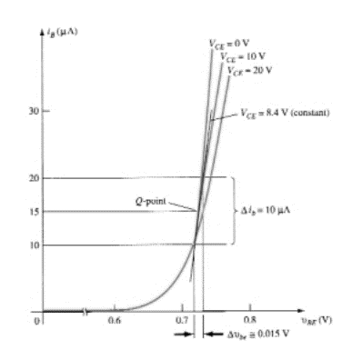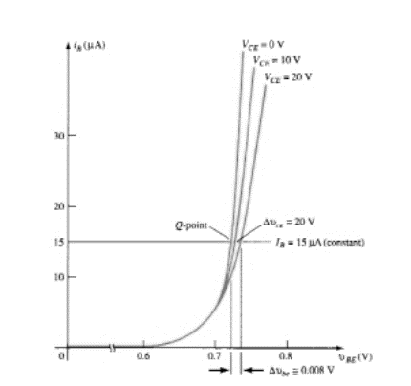
Fig. 6 Fig. 7

- Using the characteristics of Fig. 8, design a voltage-divider circuit with a saturation current level of 10 mA and a Q-point one-half the distance between cutoff and saturation. The available supply is 28 V, and V_{E} is to be one-fifth of V_{CC}. The condition established by Equation$: βR_{E}≥10R_{2}$ should also be met to provide a high stability factor. Use standard values.
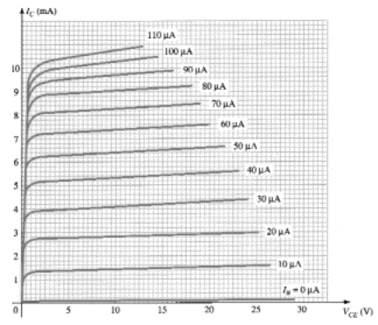
Fig. 8

